Martin Conrad

Vice President Category Management

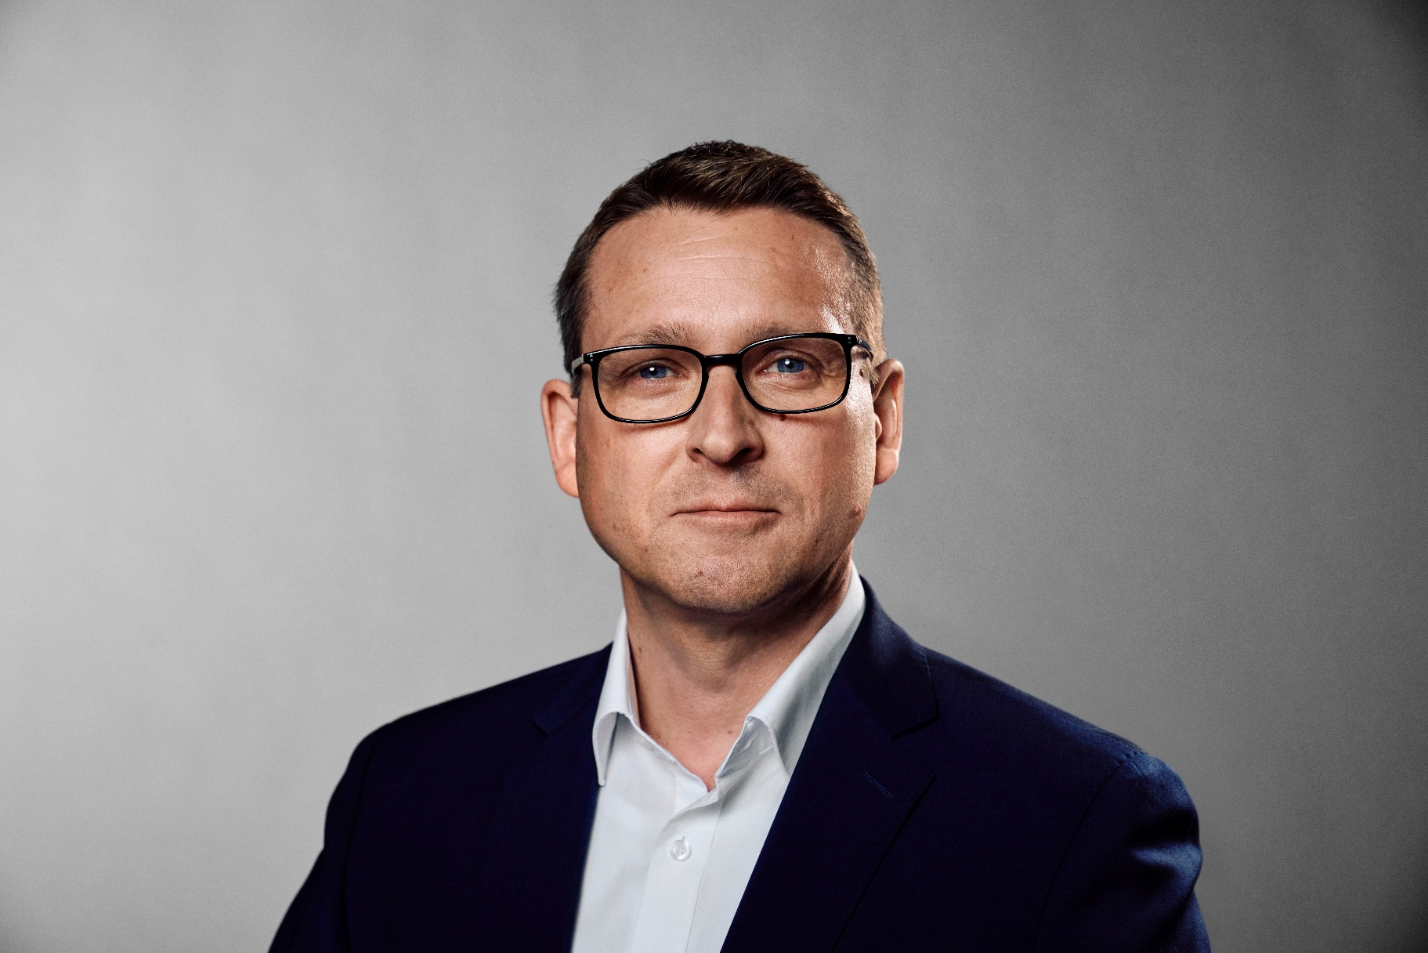

Passionate to innovate and drive progress

Martin Conrad is Vice President of Category Management, he joined LKQ Europe in February 2020 as Vice President of Components, after holding roles as Chief Executive Officer and Chief Financial Officer for the German automotive wholesale supplier   
PV Automotive (part of LKQ Europe) for 8 years.

At PV Automotive he developed with his board colleagues a new business strategy and focused on operational excellence to recover from a loss-making situation.

Martin Conrad started his career in the audit practice of the Big Four firm PricewaterhouseCoopers (PWC), working later on in transaction services. During the six years with PWC he took the US CPA exam as well  
as the German CPA exam. He moved to the banking industry working for Investkredit Bank for around   
six years, heading a leveraged finance team for the Western European market. During this period he successfully increased the loan portfolio x 10 with  
his team.

During his time at PWC and Investkredit  
he advised and financed numerous transactions  
in the automotive supplier industry.

Before joining PV Automotive he spent two years  
with the audit and advisory firm PKF as a Partner  
in Corporate Finance. In his current role, Martin is responsible for our aftermarket product brand portfolio.

“Our customers daily needs are at the heart  
of everything we do. We want to offer them the most comprehensive one stop shop aftermarket product brand portfolio.