Gwendoline Rousse

Senior Director Transformation, LKQ Europe

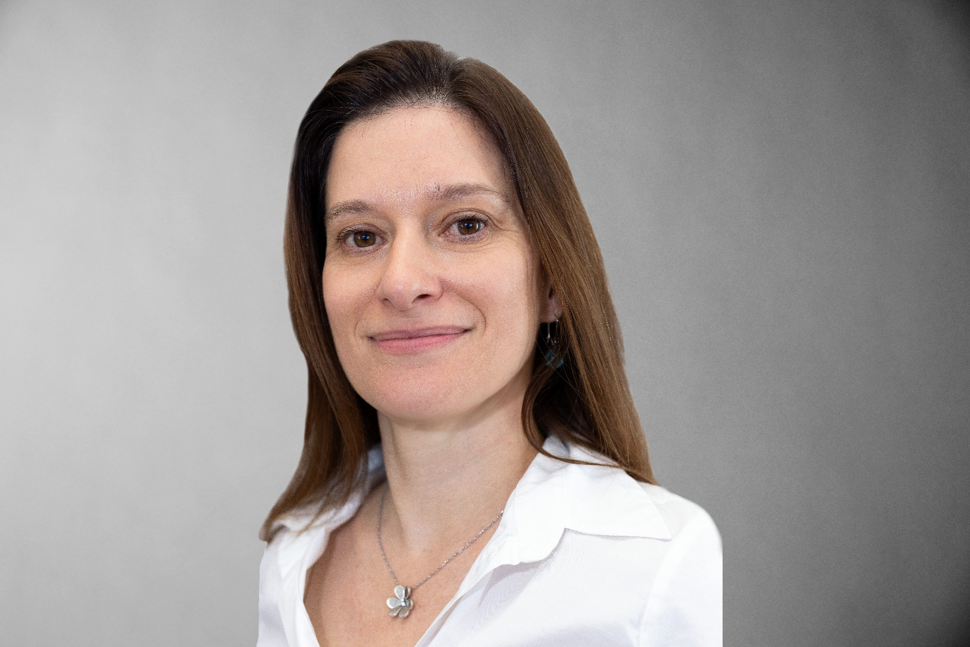

Accelerating efficiency, innovation,   
and sustainable business success

Gwendoline Rousse serves as Senior Director Transformation for LKQ Europe. Having joined LKQ   
in February 2025, Gwendoline’s role places her at the forefront of driving transformation, efficiency, and sustainable business outcomes. With a proven track record in leading change, technology implementation, customer experience improvements, and financial management, she brings a people-focused and data-driven approach to transformation.

Gwendoline is a seasoned executive with over 18 years of international experience driving large-scale transformations, post-merger integrations, and operational excellence across multiple industries.   
She specializes in aligning strategic vision with execution, optimizing business processes,   
and leading multicultural teams through complex organizational change.

Throughout her career, she has held senior leadership roles at SIX Group, overseeing operational excellence, business management, and pricing on a global scale. She is recognized for her ability to lead cross-functional teams, manage high-level stakeholder relationships, and implement cutting-edge automation technologies such as AI, robotics,   
and digital workflows.

Passionate about mentorship and diversity, Gwendoline actively supports talent development programs and gender equality initiatives. She has supported Advance, Switzerland’s leading business association for gender equality. When she’s not driving business transformation, Gwendoline enjoys climbing, hiking, and exploring new challenges—both in and outside of the corporate world.

“Transformation happens when vision meets execution, technology empowers people, and strategy drives impact.